Date: 09/06/2021

Author: Naveen Bandepalya

**Design and detailing of BIW Spot welding Fixtures for a European OEM**

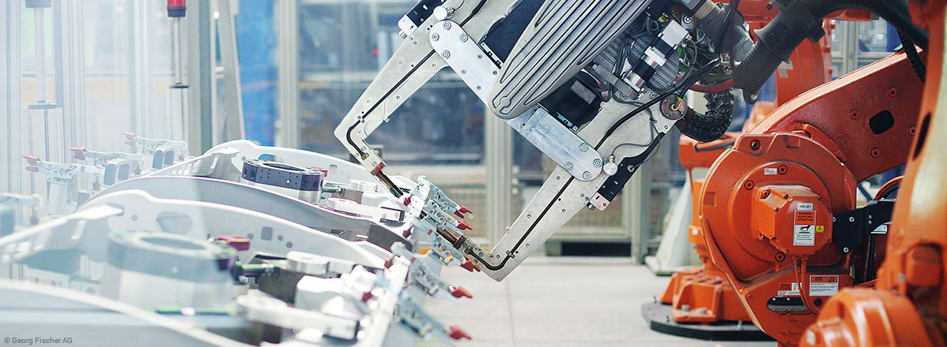

5 Geo spot fixtures, 1 re-spotting fixture and 1 mastic application fixture for SIDE PANEL assembly

**1**

**PROJECT SCOPE**

Design validation of these fixtures using Robcad by simulating spot welding gun access

**3**

5 Geo spot fixtures, 1 MIG welding fixtures and 3 Re-spotting fixtures for FRAMING line

**2**

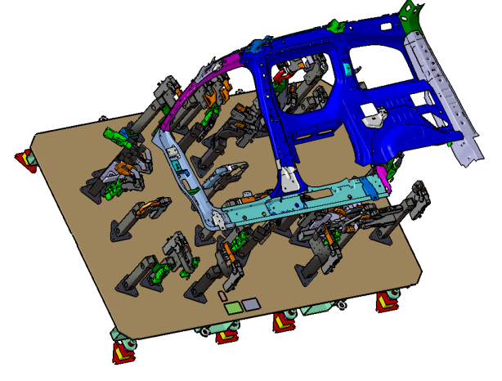

Assembly and manufacturing drawing creation of all the above 16 fixtures

**4**

**TOOLS USED**

* CATIA V5
* Robcad

**Variants**

**KEY CHALLENGES**

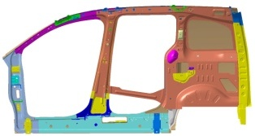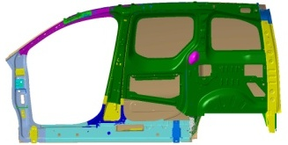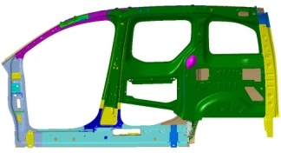

* Each Fixture to process 5 variants of PANEL assembly with minimum change over time.
* Fixture to be designed for manual spot welding while meeting the operator ergonomic requirement of the OEM.
* Fixture design to meet Cycle time proposed by the OEM.
* Number of Operator & guns per station planning for meeting cycle time and proposed plant layout by the OEM

**Operator Ergonomics**

**INPUTS**

**Spot List**

**Working heights for critical stations**

**Process sequence & Plant layout**

**PLP/ Clamping Plan.**

**LAYOUT**

Our team studied and prepared a layout, which meets manufacturing plant ergonomic requirements.

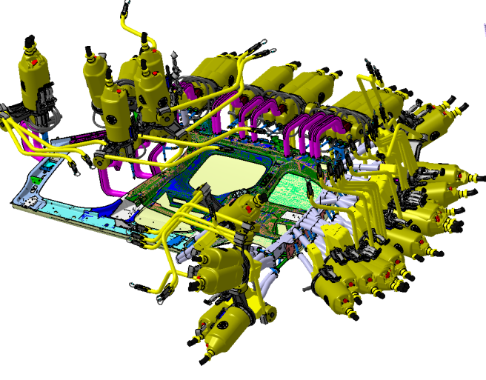

**BIW sub assembly transportation unit concept creation**

**Gun selection and rough positioning for subsequent Fixture Design stage.**

**BIW sub assembly Transportation & Working Height /station layout creation**

**3D DATA CREATION**

Detailed engineering 3D data created using CATIA V5 tool.

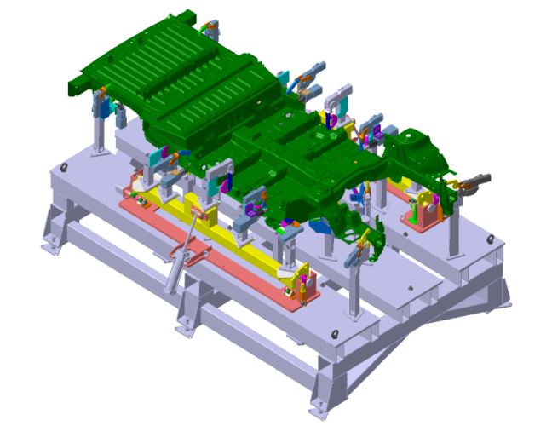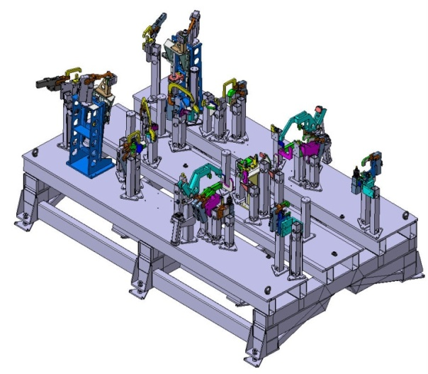

**Framing line station**

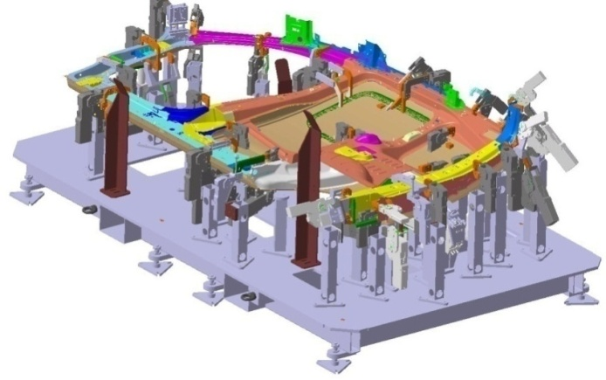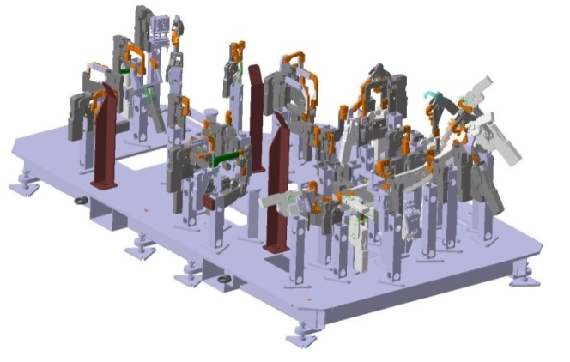

**Body Side marriage station**

**VALIDATION**

ROBCAD analysis for Gun access study

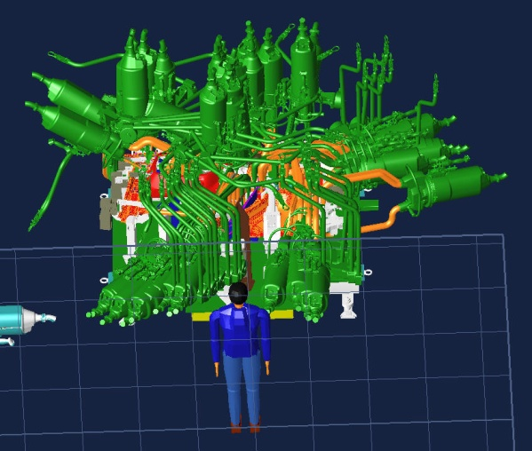

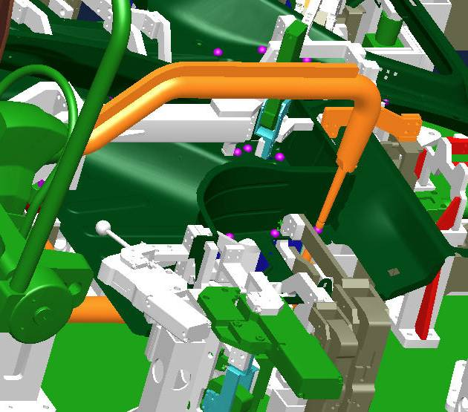

**Clashes and accessibility concerns identified in ROBCAD were corrected in design with few iterations**

**DELIVERABLES**

**Reports**

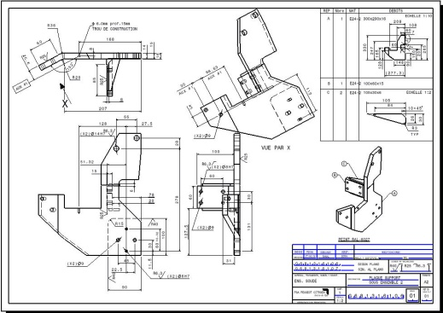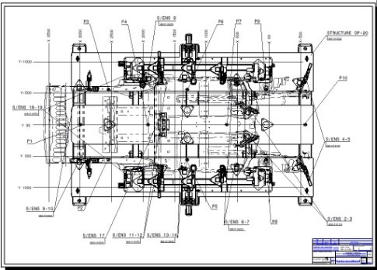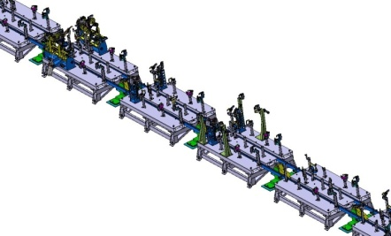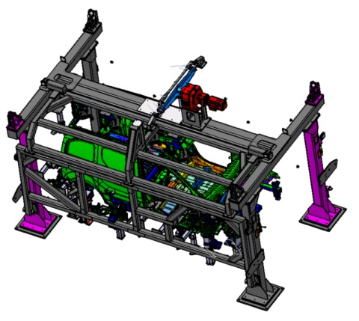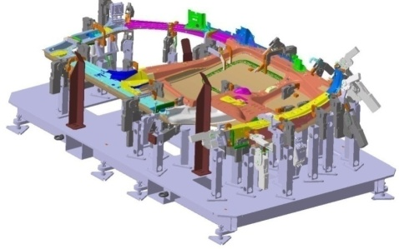

* 2D detailed manufacturing drawing
* Assembly drawings & BOM

**Drawings & BOM**

* ROBCAD analysis report with detail view for each spot
* Ergonomics study report
* Spot distribution per station
* & Cycle time report
* Gun definition per station

**3D CAD data**